37.26: Using 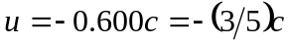 in Eq. (37.25) gives
